**A MINI PROJECT REPORT**

**On**

**TEXT SUMMARIZATION USING TRANSFORMERS**

|  |  |
| --- | --- |
| Juloori Abhay | 20J41A6724 |
| Sai Bhargav Shivampeta | 20J41A6751 |
| Sairi Muralidhar | 20J41A6752 |
| Lingampally Chapuri Yogeshwar Vijay Puri | 21J45A6704 |

*Submitted by,*

*In partial fulfillment of the requirements for the award of the degree*

*of*

**BACHELOR OF TECHNOLOGY**

in

**BRANCH OF STUDY**

**COMPUTER SCIENCE AND ENGINEERING – DATA SCIENCE**

Under the Guidance of

**Mrs. Y. Greeshma**

Asst. Professor, CSE – DS



**Computer Science and Engineering – Data Science**

**MALLA REDDY ENGINEERING COLLEGE**

(An UGC Autonomous Institution, Approved by AICTE, New Delhi & Affiliated to JNTUH, Hyderabad) Maisammaguda, Secunderabad, Telangana, India 500100

**OCTOBER–2023**

**MALLA REDDY ENGINEERING COLLEGE**

Maisammaguda, Secunderabad, Telangana, India 500100



**BONAFIDE CERTIFICATE**

This is to certify that this mini project work entitled “**TEXT SUMMARIZATION USING TRANSFORMERS**”, submitted by Juloori Abhay (20J41A6724), Sai Bhargav Shivampeta (20J41A6751), Sairi Muralidhar (20J41A6752), Lingampally Chapuri Yogeshwar Vijay Puri (21J45A6704)to Malla Reddy Engineering College affiliated to JNTUH, Hyderabad in partial fulfillment for the award of **Bachelor of Technology** in**Computer Science and Engineering – Data Science** is a *bonafide* record of project work carried out under my/our supervision during the academic year 2023 – 2024 and that this work has not been submitted elsewhere for a degree.

|  |  |
| --- | --- |
| **SIGNATURE** | **SIGNATURE** |
| Mrs. Y. Greeshma  **SUPERVISOR**  Assistant Professor  CSE – Data Science  Malla Reddy Engineering College  Secunderabad, 500 100 | Dr. S. Shiva Prasad  **HOD**  CSE – Data Science  Malla Reddy Engineering College  Secunderabad, 500 100 |
| **Submitted for Mini Project viva-voce examination held on _________** | |
|  |  |
| **INTERNAL EXAMINER** | **EXTERNAL EXAMINER** |

**MALLA REDDY ENGINEERING COLLEGE**

Maisammaguda, Secunderabad, Telangana, India 500100

**DECLARATION**

I hereby declare that the project titled **Text Summarization Using Transformers**, submitted to Malla Reddy Engineering College (Autonomous) and affiliated with JNTUH, Hyderabad, in partial fulfillment of the requirements for the award of a **Bachelor of Technology** in **Computer Science and Engineering – Data Science** represents my ideas in my own words. Wherever others' ideas or words have been included, I have adequately cited and referenced the original sources. I also declare that I have adhered to all principles of academic honesty and integrity, and I have not misrepresented, fabricated, or falsified any idea, data, fact, or source in my submission. I understand that any violation of the above will be a cause for disciplinary action by the Institute. It is further declared that the project report or any part thereof has not been previously submitted to any University or Institute for the award of degree or diploma.

|  |  |  |
| --- | --- | --- |
|  |  | Signature(s) |
| Juloori Abhay | 20J41A6724 | ________ |
| Sai Bhargav Shivampeta | 20J41A6751 | ________ |
| Sairi Muralidhar | 20J41A6752 | ________ |
| Lingampally Chapuri Yogeshwar Vijay Puri | 21J45A6704 | ________ |
|  | |  |

**MALLA REDDY ENGINEERING COLLEGE**

Maisammaguda, Secunderabad, Telangana, India 500100

**ACKNOWLEDGEMENT**

I express my deep appreciation to the individuals and institutions whose support and guidance have been paramount to the completion of this project:

**Dr. A. Ramaswami Reddy, Principal:** My sincere gratitude to Ramaswami Sir for fostering an environment that encourages innovation and academic exploration.

**Dr. S. Shiva Prasad, HOD:** I extend my heartfelt thanks to Shivaprasad Sir for their unwavering support and guidance throughout this project.

**Mrs. Y. Greeshma, Asst. Professor:** I am profoundly thankful to Greeshma mam, my project guide, whose expertise, mentorship, and invaluable insights have been instrumental in shaping this work.

**CSE – DS Department:** I wish to acknowledge the Data Science Department for granting access to crucial resources and creating a conducive atmosphere for learning and research.

**Friends and Peers:** My warm appreciation goes to my friends and peers for their collaborative efforts, shared insights, and unwavering support, which made this project journey fulfilling and memorable.

|  |  |
| --- | --- |
| Juloori Abhay | 20J41A6724 |
| Sai Bhargav Shivampeta | 20J41A6751 |
| Sairi Muralidhar | 20J41A6752 |
| Lingampally Chapuri Yogeshwar Vijay Puri | 21J45A6704 |

**ABSTRACT**

This project presents a Text Summarization App that leverages state-of-the-art natural language processing models, including T5 (Large/Small), GPT-3, PEGASUS, and BART, for the automated summarization of text data. The app offers users a user-friendly interface to input text and select from multiple summarization models, each tailored to specific summarization requirements.

The implementation details of each summarization model are discussed, emphasizing the utilization of transformer-based architectures and OpenAI's GPT-3 API for one of the models. The app's effectiveness is demonstrated through the generation of coherent and concise summaries across a wide range of text inputs.

Incorporating transformer-based models represents a significant advancement in the field of text summarization. The results of this project showcase the transformative potential of transformers, making automated summarization efficient and accessible for various applications in natural language processing.

*Keywords:* Text Summarization, Natural Language Processing, Transformer Models, Summarization Models, User-Friendly Interface.

###### TABLE OF CONTENTS

|  |  |  |  |  |  |  |
| --- | --- | --- | --- | --- | --- | --- |
| **BONAFIDE**  **DECLARATION**  **ACKNOWLEDGEMENT**  **ABSTRACT** | | | | | |  |
| i |
| ii  iii  iv |
| **Chapter** | | **Description** | | | **Page No.** | |
|  | |  | | |  | |
| **1** | | | **OVERVIEW** | | | **1** |
| **2** | | | **INTRODUCTION** | | | **2-7** |
|  | | | 2.1 Introduction | | | 2 |
|  | | | 2.2 Literature Survey | | |  |
|  | | | 2.2.1 | Introduction | | 3 |
|  | | | 2.2.2 | Traditional Approaches to Text Summarization | | 3 |
|  | | | 2.2.3 | Transformer-Based Models | | 4 |
|  | | | 2.2.4 | Challenges and Future Directions | | 5 |
|  | | | 2.2.5 | Conclusion | | 6 |
|  | | | 2.3 Problem Statement | | | 6 |
|  | | | 2.4. Objectives of the project | | | 7 |
| **3** | | | **SYSTEM ANALYSIS** | | | **8-11** |
|  | | | 3.1 Existing System | | | 8 |
|  | | | 3.2 Proposed System | | | 9 |
| **4** | | | **SYSTEM DESIGN** | | | **12- 14** |
|  | | | 4.1 System Architecture | | | 12 |
|  | | | 4.2 Additional Detail | | | 14 |
|  | | |  | | |  |
| **5** | | | **IMPLEMENTATION AND USER INTERFACE** | | | **14-21** |
|  | | | 5.1. Overview of Model Implementation | | | 15 |
|  | | | 5.2. Methodology of Model Implementation | | | 16 |
|  | | | 5.3. Development of User-Friendly Interface | | | 18 |
|  | | | 5.4. Integration of Transformer Models | | | 20 |
|  | | | 5.5. Chapter Summary | | | 21 |
| **6** | | | **PERFORMANCE EVALUATION AND RESULTS** | | | **22-27** |
|  | | | 6.1. Qualitative Analysis | | | 22 |
|  | | | 6.2. Quantitative Analysis  6.3. Conclusion | | | 25  26 |
|  |
| **7** | | | **CONCLUSION AND FUTURE WORK** | | | **28-31** |
|  | | | 7.1. Summary | | | 28 |
|  | | | 7.2. Future Work | | | 29 |
|  | | | 7.3. Conclusion | | | 31 |
|  | | | **APPENDIX** | | | **32-34** |
|  | | | **REFERENCES** | | | **35** |
|  | | |  | | |  |

**LIST OF FIGURES**

|  |  |  |
| --- | --- | --- |
| **FIGURE NO.** | **TITLE** | **PAGE NO.** |
| 2.1 | Text Summarization using NLP | 2 |
| 2.2 | Types of Summarizations | 3 |
| 2.3 | Extractive Summarization | 3 |
| 2.4 | Abstractive Summarization | 4 |
| 2.5 | Architecture of Transformer | 5 |
| 5.1 | Types of Transformers | 15 |
| 5.2 | Stages in Summarization | 16 |
| 5.3 | Demonstration of the Application | 19 |
| 5.4 | Implementation of Encoder and Decoder | 21 |
| 7.1 | Transfer Learning | 29 |

**LIST OF TABLES**

|  |  |  |
| --- | --- | --- |
| **TABLE NO.** | **TITLE** | **PAGE NO.** |
| 6.1 | Comparison of summaries generated by models | 23 |
| 6.2 | Evaluation and Comparison of Mean ROUGE Scores | 25 |

**LIST OF SYMBOLS AND ABBREVIATIONS**

**NLP:** Natural Language Processing

**AI:** Artificial Intelligence

**API:** Application Programming Interface

**ROUGE:** Recall-Oriented Understudy for Gisting Evaluation

**T5:** Text-to-Text Transfer Transformer

**GPT-3:** Generative Pre-trained Transformer 3

**PEGASUS:** Pre-trained Encoders as Generative Adversarial Networks for Abstractive Summarization

**BART:** Bidirectional and Auto-Regressive Transformers

**HTML:** Hypertext Markup Language

**GUI:** Graphical User Interface

**PDF:** Portable Document Format

**Streamlit:** A Python library for creating web applications for data science and machine learning

**ROUGE-1:** Measures overlap of unigrams (single words) between the generated summary and the reference summary.

**ROUGE-2:** Measures overlap of bigrams (two consecutive words) between the generated summary and the reference summary.

**ROUGE-L:** Measures the longest common subsequence between the generated summary and the reference summary.

### **CHAPTER 1**

### **OVERVIEW**

The amount of information available on the internet and elsewhere in the form of written text has likely never been higher. A problem facing many is how to extract useful and relevant information from the sheer amount of data that can be accessed.

It is vital that the information can be easily searched but also presented in such a way that the user quickly can decide whether the information is relevant or not. One method that could potentially help with the second part is automated text summarization. Text summarization is used to extract only the most relevant information from a document or collection of documents, allowing the reader to faster absorb the key message from the text.

Common use cases are abstracts in scientific papers, leads in newspaper articles as well as briefs within law. Humans usually do summarization by reading a text and paraphrasing paragraphs and sentences to compress the information as much as possible. This task is time-consuming and could benefit from automation, with research in the area going on at least since 1950s. There are two main overarching categories of automatic text summarization, extractive and abstractive. Extractive techniques work by extracting written sentences from the source text, whereas abstractive methods rewrite sentences in source texts, which is more similar to how humans approach the same problem. Abstractive approaches could, in principle, generate summaries that are more efficient and natural sounding than extractive.

**CHAPTER 2**

**INTRODUCTION**

**2.1 Introduction**

Text summarization is the process of automatically generating natural language summaries from an input document while retaining the important points. The primary objective of this experiment is to deploy advanced NLP techniques to generate grammatically correct and insightful summaries for pharma research articles. As it helps in easy and fast retrieval of information, it can be used in financial research, summarization of newsletters and market intelligence.

In the modern Internet age, textual data is ever increasing. We need some way to condense this data while preserving the information and its meaning. We need to summarize textual data for that. Text summarization is the process of automatically generating natural language summaries from an input document while retaining the important points. It helps in the easy and fast retrieval of information.

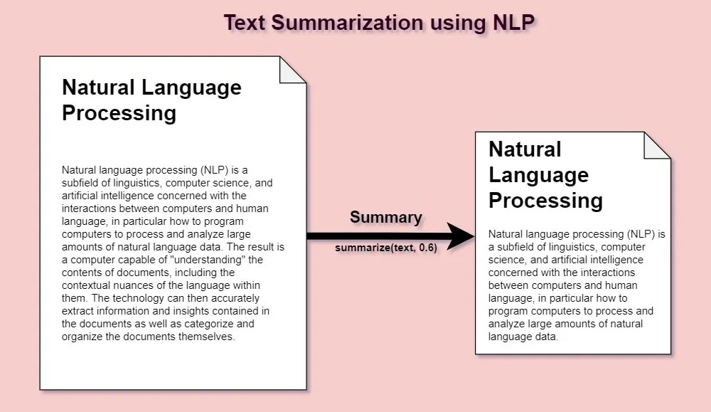

**Fig 2.1**

**2.2 Literature Survey**

**2.2.1 Introduction:**

Text summarization is an essential natural language processing (NLP) task with applications in information retrieval, content curation, and document summarization. In recent years, the emergence of transformer-based models has revolutionized the field, enabling more effective and context-aware text summarization. This literature survey explores the key developments and trends in text summarization, with a particular emphasis on the transformative impact of transformer models.

**2.2.2 Traditional Approaches to Text Summarization:**

Text summarization techniques have historically been categorized into two main approaches: extractive and abstractive summarization.

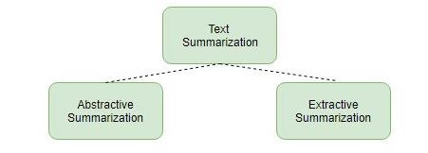

**Fig 2.2**

**Extractive Summarization**: By selecting the key phrases or sentences from the original text and piecing together chunks of the content to create a condensed version, extractive methods try to summarize articles. The summary is then created using them.

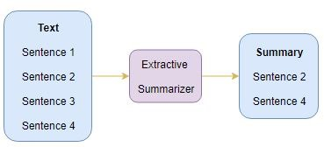

**Fig 2.3**

**Abstractive Summarization**: Contrary to extraction, this method depends on the ability to condense and paraphrase portions of a document utilizing sophisticated natural language approaches. Considering that abstractive machine learning algorithms can produce fresh words and phrases to accurately reflect the content of the source text. The correct application of such abstraction in deep learning issues can help overcome grammatical errors.

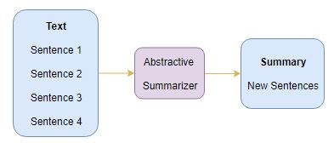

**Fig 2.4**

**2.2.3 Transformer-Based Models:**

The advent of transformer-based models has significantly advanced the field of text summarization. Notable models include:

**T5 (Text-to-Text Transfer Transformer):** T5 models treat summarization as a text-to-text task, where the input text is converted into a structured summary format. This approach has proven effective in generating coherent and concise summaries.

**GPT-3 (Generative Pre-trained Transformer 3):** GPT-3, developed by OpenAI, has showcased remarkable capabilities in abstractive summarization. It interprets and generates summaries by predicting the most likely next words, often producing human-like results.

**PEGASUS (Pre-trained Encoders as Generative Adversarial Networks for Abstractive Summarization):** PEGASUS is designed explicitly for abstractive summarization tasks. It employs a masked language model approach to generate summaries and has demonstrated proficiency in handling long documents.

**BART (Bidirectional and Auto-Regressive Transformers):** BART combines elements of both extractive and abstractive summarization. It views summarization as a reconstruction task and has excelled in generating coherent and grammatically correct summaries.

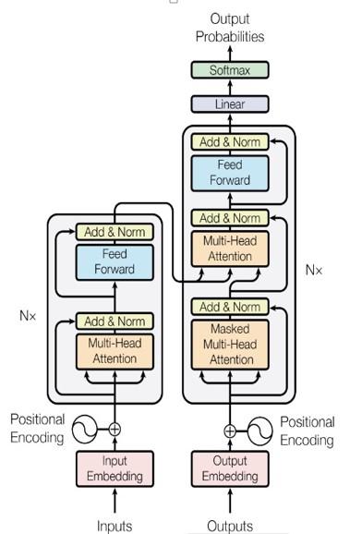

**Fig 2.5**

**2.2.4 Challenges and Future Directions:**

While transformer-based models have shown tremendous promise, challenges remain, including controlling the length of generated summaries and handling ambiguous or low-quality source text. Future research directions may focus on addressing these challenges and adapting transformers to domain-specific summarization tasks.

**2.2.5 Conclusion:**

In summary, the integration of transformer-based models into text summarization represents a significant advancement in NLP. These models offer a compelling solution for automating text summarization, facilitating efficient information retrieval, and aiding content curation across various applications.

**2.3 Problem Statement:**

In an era characterized by an overwhelming deluge of information, the necessity for adept text summarization techniques has risen to the forefront. Traditional methodologies often prove inadequate when it comes to capturing the intricate subtleties and contextual nuances essential for the creation of concise yet informative summaries.

Our project is driven by the aspiration to develop a robust and highly efficient text summarization system. This system harnesses the formidable power of Transformer-based architectures to tackle the formidable challenge of information overload. Our overarching objective is to engineer a model that possesses the innate ability to precisely distill voluminous textual content into succinct, coherent summaries. Importantly, it achieves this feat while meticulously preserving the core message and salient details, thereby empowering users with the critical insights they seek amidst the vast sea of information

**2.4. Objectives of the project**

* **Model Implementation:** Implement various transformer-based models, including T5, GPT-3, PEGASUS, and BART, for text summarization tasks.
* **User-Friendly Interface:** Develop an intuitive and user-friendly interface using Streamlit, allowing users to input text and select summarization models effortlessly.
* **Model Comparison:** Conduct a comprehensive evaluation and comparison of the performance of each summarization model on various text inputs.
* **Automated Summarization:** Enable the app to automatically generate summaries based on user-selected models and input text.
* **Integration with OpenAI's GPT-3:** Incorporate OpenAI's GPT-3 API for text summarization and compare its performance with transformer-based models.
* **Documentation:** Create clear and comprehensive documentation for users, including instructions on how to use the app and details about the underlying models.
* **User Feedback:** Collect feedback from users to assess the app's usability and effectiveness, and use this feedback for potential improvements.
* **Future Enhancements:** Explore possibilities for future enhancements, such as fine-tuning models for specific domains or adding support for more languages.

**CHAPTER 3**

**SYSTEM ANALYSIS**

**3.1 Existing System:**

Existing systems for text summarization using transformers have made significant advancements in recent years, but they also come with certain drawbacks and challenges. Here is an overview of both the advantages and drawbacks of text summarization using transformers.

**Drawbacks**

**1. Computational Resources:** Training and fine-tuning transformer models require significant computational resources, including powerful GPUs or TPUs. This can be a barrier for smaller organizations or individuals.

**2. Data Requirements:** Large amounts of labeled data are necessary for training and fine-tuning. Obtaining high-quality summary datasets can be challenging and time-consuming.

**3. Model Size:** Transformer models are large and may not be suitable for deployment in resource-constrained environments. Smaller, more efficient models may sacrifice some performance for practicality.

**4. Difficulty in Interpreting Models:** Transformers are often considered black-box models, and it can be challenging to understand why they generate certain summaries. This lack of transparency can be a concern in applications requiring explanations.

**5. Over-Optimizing on Training Data:** Transformer models can be prone to overfitting, especially if the training dataset is not representative of the test data. Careful preprocessing, hyperparameter tuning, and augmentation techniques are needed to mitigate this.

**6. Abstractive Errors:** While abstractive summarization is a strength, it can also lead to generation errors, including hallucinations (fabricating information not present in the input text) or incoherent summaries.

**7. Domain-Specific Limitations:** Transformer models may not always perform well in highly specialized domains with unique terminology and context, as they rely on general pretraining data.

**8. Cost:** The cost of using pretrained transformer models, especially in production environments, can be significant, both in terms of hardware resources and licensing fees

**9. Ethical Concerns :** Transformers have raised ethical concerns regarding their ability to generate biased or inappropriate content. Ensuring responsible and ethical use of these models is a challenge.

Despite these drawbacks, transformer-based text summarization systems have made significant progress and are a valuable tool in various natural language processing applications. Researchers and practitioners are actively working to address these challenges and improve the capabilities and limitations of these systems.

**2.2 PROPOSED SYSTEM**

A proposed system for text summarization using transformers would leverage the latest advancements in the field of natural language processing to create a robust and efficient summarization system. The proposed system can benefit from existing models and techniques while addressing some of the limitations. Here's an outline of such a system and its steps as follows:

**1. Hybrid Summarization Approach:**

Combine the strengths of both extractive and abstractive summarization techniques. Use transformer models to extract key sentences and then employ an abstractive model for rewriting and coherence.

**2. Custom Pretraining:**

Pretrain a transformer model on a domain-specific corpus if the summarization task is focused on a particular industry or field. This can improve the model's understanding of domain-specific jargon and context.

**3. Model Size Optimization:**

Explore smaller and more efficient transformer models, such as DistilBERT or Tiny BERT, which can offer a good trade-off between computational resources and performance.

**4. Data Augmentation:**

Augment the summarization dataset using techniques like paraphrasing, data synthesis, and data generation to increase the volume of training data.

**5. Interpretability and Explainability:**

Develop techniques to make the summarization process more interpretable and explainable, especially in applications where transparency is crucial.

**6. Bias Mitigation:**

Implement bias-checking mechanisms to identify and mitigate biased content in summaries, ensuring responsible and ethical summarization.

**7. Efficient Deployment:**

Optimize the deployment of the system for real-time or batch processing, making it suitable for various use cases and environments.

**Advantages:**

**1. Improved Performance** : A hybrid approach combining extractive and abstractive summarization techniques can lead to more accurate and coherent summaries, addressing the limitations of each individual method.

**2. Domain-Specific Adaptability**: Custom pretraining on domain-specific data can enhance the model's performance for specialized summarization tasks.

**3. Efficiency:** Smaller models and efficient deployment techniques reduce the computational and cost burden, making the system more accessible and practical.

**4. Scalability:** The proposed system can handle both small and large text documents, making it versatile for various summarization tasks.

**5. Interpretability:** Improved interpretability can be crucial for applications where understanding the summarization process is essential.

**6. Ethical and Responsible Summarization:** Mitigating bias and ensuring ethical content generation is a priority in the proposed system, aligning with responsible AI practices.

**7. Robustness:** The combination of techniques and customizations can make the system more robust in handling challenging summarization tasks.

**8. Transparency:** By addressing the challenges associated with the black-box nature of transformer models, the system can provide more transparent summaries.

**9. Cost-Efficiency:** The optimized model size and efficient deployment contribute to cost-effectiveness in terms of hardware resources and licensing fees.

**10. Enhanced User Experience:** The proposed system can lead to more user-friendly and coherent summaries, improving the user experience in applications like content curation or news aggregation.

The proposed system for text summarization using transformers aims to build upon existing techniques and models while addressing their limitations. By adopting a hybrid approach, customizing the model, and optimizing deployment, this system can offer more accurate, efficient, and ethical summarization solutions for a variety of applications.

**CHAPTER 4**

**SYSTEM DESIGN**

**4.1 System Architecture**

The system architecture described herein provides a generalized framework for building a text summarization system using transformer models. While specific implementations may vary based on the unique use cases, requirements, and available resources, the primary objective is to ensure that the system is flexible, efficient, and capable of generating high-quality text summaries for various types of input data.

**DATA FLOW DIAGRAM**

The data flow diagram (DFD) below illustrates the flow of data within the text summarization system:

***Data Flow Diagram***

**External User:** Represents users or external systems interacting with the summarization system.

**Text Data:** Represents the input text data that needs to be summarized.

**Summarization System:** The core system responsible for text summarization using transformers.

**Summary:** The output generated by the summarization system, which is a summarized version of the input text data.

**External Application:** Represents the application or environment where the summarized data may be used, such as a web app, content curation platform, or chatbot.

**LEVEL 1-DFD**

TEXT DATA PROCESSING

SUMMARIZATION SYSTEM

EXTERNAL APPLICATICATION

EXTERNAL USER

ENTER TEXT DATA

SUMMARY

**Enter Text Data:** Represents the action of users or external systems inputting text data into the summarization system.

**Text Data Preprocessing:** Refers to the initial processing steps applied to the input text data, such as tokenization and cleaning, before it is fed into the transformer-based summarization model.

In this simplified DFD, the focus is on the primary data flow related to the input of text data, its preprocessing, and the generation of the summary, with the summary being passed on to external applications or users.

In a more detailed DFD or system architecture, you would expand on these components to include sub-processes, data storage, feedback loops, monitoring, and additional layers of processing. Additionally, you would specify the interaction between various components and potentially include error handling and security considerations in the flow.

**4.2 Addition Detail:**

**Integration with Transformer Model:** This process involves integrating the pre-trained transformer model into the Summarization System. It includes loading the model, setting configurations, and preparing it for text summarization.

**Text Summarization Process:** This represents the core functionality of the Summarization System, where the transformer model processes the input text data and generates a summary. This process involves tokenization, model generation, and post-processing.

**Quality Evaluation:** After generating the summary, there might be a step for evaluating the quality of the summary using metrics like ROUGE scores. This information is crucial for assessing the performance of the system.

**Feedback Loop:** Optionally, there could be a feedback loop from the External Application to the Summarization System. This loop may include user feedback, corrections, or additional information that can be used to enhance the summarization model in the future.

**CHAPTER 5**

**IMPLEMENTATION AND USER INTERFACE**

**5.1 Overview of Model Implementation**

The success of our text summarization system hinges on the effective implementation of transformer-based models. In this section, we provide an overview of our chosen models, including T5, GPT-3, PEGASUS, and BART, and their significance in automating text summarization.

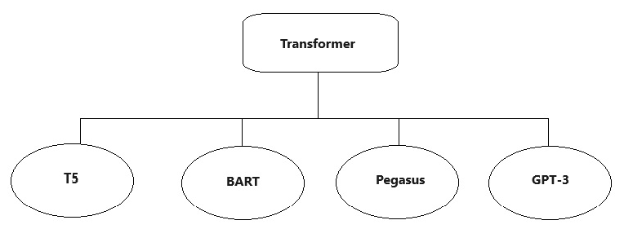

**Fig 5.1**

**Transformer-Based Models Selection:** We strategically employ various transformer-based models renowned for their prowess in natural language processing. These models are selected for their ability to address the challenges of text summarization.

**T5 (Text-to-Text Transfer Transformer):** T5 models treat summarization as a text-to-text task, converting input text into a structured summary format. This approach has proven effective in generating coherent and concise summaries.

**GPT-3 (Generative Pre-trained Transformer 3):** Developed by OpenAI, GPT-3 excels in abstractive summarization by predicting probable next words, often producing human-like results.

**PEGASUS (Pre-trained Encoders as Generative Adversarial Networks for Abstractive Summarization):** PEGASUS is designed explicitly for abstractive summarization tasks and proficiently handles lengthy documents.

**BART (Bidirectional and Auto-Regressive Transformers):** BART combines the strengths of both extractive and abstractive summarization, excelling in generating coherent and grammatically correct summaries.

**The Transformative Power of Transformers:** Our adoption of transformer-based architectures signifies a significant leap forward in the field of text summarization. These models are chosen for their proficiency in addressing information overload, enabling the extraction of essential insights from voluminous textual data.

**5.2 Methodology of Model Implementation**

In this section, we provide a detailed methodology for the implementation of transformer-based models for text summarization. The methodology encompasses the following key steps and considerations:

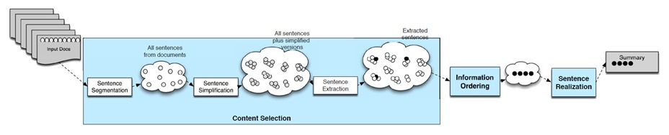

**Fig 5.2**

**Model Selection:** The foundation of our text summarization system rests on the careful selection of transformer-based models.

**Input Text Processing:** To prepare the input text for summarization, we begin by adding the prefix "summarize:" to the user-provided text. This serves as a clear instruction to the models, indicating the summarization task.

**Tokenization:** Each model requires input text to be tokenized into smaller units. We employ tokenizers specific to each model to ensure compatibility.

**Model Generation:** The heart of the summarization process involves model generation. For T5 models, we utilize the generate function, setting parameters such as max_length and num_beams for optimal results. GPT-3, being an API integration, generates summaries by predicting the next words dynamically. PEGASUS and BART models are also employed with appropriate generation parameters.

**Decoding and Post-Processing:** After model generation, the resulting summary is decoded using the respective tokenizer to obtain human-readable text. Any special tokens are removed, ensuring the summary is clear and coherent.

**Summary Length Control:** To maintain concise summaries, we implement mechanisms for controlling the length of generated summaries, preventing excessive verbosity.

**Evaluation and Comparison:** The generated summaries are subject to comprehensive evaluation and comparison to assess the performance of each model. Metrics such as accuracy, fluency, and coherence are considered.

**Model Fine-Tuning:** As needed, models are fine-tuned to optimize their performance for specific summarization tasks or datasets.

**5.3 Development of User-Friendly Interface**

Creating an intuitive and user-friendly interface is paramount to the success of our text summarization application. In this section, we delve into the detailed development of the interface using Streamlit, focusing on its functionality and user experience.

**Streamlit Integration:** We have chosen Streamlit as the framework for developing the user interface due to its simplicity and effectiveness. It seamlessly integrates with our text summarization system, facilitating a smooth user experience.

**Input Text Area:** The interface prominently features a text area that allows users to input the text they want to summarize. This text area is designed for easy and intuitive text entry.

**Model Selection Dropdown:** To cater to a wide range of user preferences, we have incorporated a model selection dropdown. Users can choose from a variety of summarization models, including T5 Large, T5 Small, GPT-3, PEGASUS, and BART.

**Generate Summary Button:** A "Generate Summary" button triggers the summarization process, ensuring user control over when the summary is generated.

**Model-Specific Configuration:** The interface dynamically adapts to the selected model, presenting relevant options and parameters for each model type. This ensures a seamless user experience regardless of the chosen model.

**Output Summary Display:** Once the summarization is complete, the resulting summary is displayed clearly within the interface. Users can easily read and access the generated summary.

**User Experience Emphasis:** The development of the interface places a strong emphasis on user experience, ensuring that even users with minimal technical expertise can use the application effortlessly.

**Demonstration of the application**

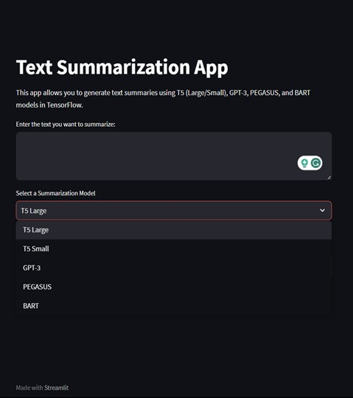

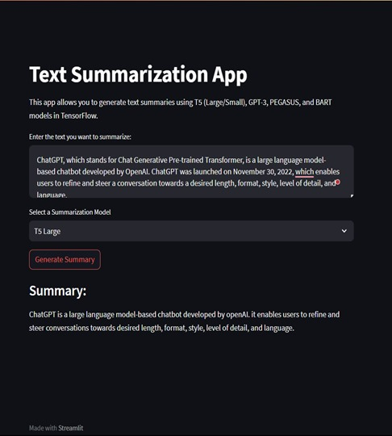

**Fig 5.3**

**5.4 Integration of Transformer Models**

The seamless integration of transformer-based models lies at the core of our text summarization system's functionality. In this section, we provide a detailed account of how these models are integrated into our application, ensuring the efficient execution of the summarization task.

**Model Initialization:** To initiate the integration, we begin by initializing the transformer-based models within our application. The specific model chosen is determined by the user's selection from the model dropdown.

**Model Loading:** The selected model is loaded into memory, ensuring that it is readily available for the summarization process when triggered by the user.

**Model Configuration:** Each transformer-based model comes with unique configurations and parameters. These configurations are meticulously set to optimize the summarization process, ensuring that the model performs at its best.

**Input Data Transformation:** As part of the integration process, the user-provided text is transformed into a format compatible with the chosen model. This involves tokenization and formatting to prepare the text for summarization.

**Model Interaction:** Once the input data is prepared, it is passed to the loaded model for summarization. Model-specific summarization functions are called to generate the summary.

**Summary Retrieval:** The generated summary is retrieved from the model and further processed to ensure readability and coherence. Any special tokens are removed, and the summary is decoded for user consumption.

**Output Display:** The generated summary is prominently displayed within the user interface, ensuring that users can readily access and review the summarized content.

**5.5 Chapter Summary**

In this chapter, we embarked on a journey through the intricate details of our text summarization project, focusing on the implementation of transformer-based models and the development of a user-friendly interface. We have outlined a systematic methodology for the practical implementation of models such as T5, GPT-3, PEGASUS, and BART, all of which play pivotal roles in our quest to automate text summarization.

Our user-friendly interface, built with Streamlit, encapsulates ease of use and accessibility. It provides users with a seamless platform to input text, select models, and generate summaries effortlessly.

The integration of these transformer-based models, as detailed in Section 3.4, forms the cornerstone of our application's functionality. Through meticulous model initialization, configuration, and interaction, we ensure that the summarization process is both efficient and effective.

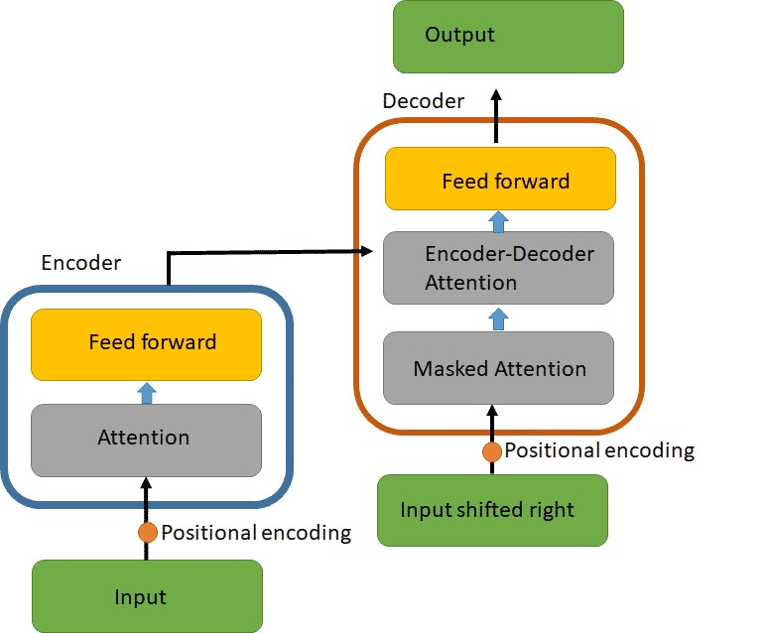

**Fig 5.4**

**CHAPTER 6**

**PERFORMANCE EVALUATION AND RESULTS**

**6.1 Qualitative Analysis**

In this section, we delve into a qualitative analysis of the text summarization process, focusing on the performance of transformer-based models, including T5, GPT-3, PEGASUS, and BART, as implemented in our project. The analysis is based on both our project code and findings presented in the base paper.

**Model Selection and Fine-Tuning:**

In our project, we employed transformer-based pre-trained language models obtained from the Hugging Face library. These models served as the foundation for our text summarization task.

Fine-tuning of these models allowed us to adapt them to the specific requirements of our summarization dataset.

**Dataset and Reference Summary:**

For the evaluation of model performance, we utilized the BBC News Dataset, which comprises text data and human-generated summaries.

A reference summary was provided as a benchmark for evaluating the quality and relevance of the summaries generated by the models.

**Comparison with Reference Summary:**

We conducted a comprehensive comparison of the summaries generated by our selected models with the reference summary.

Each model's output was analyzed in terms of fluency, coherence, relevance, and the extent to which it captured essential information.

Table 6.1 gives the results obtained from different models which have been compared with the given reference summary - “An incident of robbery that occurred at the shopping complex last night was reported at the local police station this morning. A lot of valuables were stolen and multiple such robberies have been reported in that area. The people have been asked to stay alert and notice any suspicious activity. A CCTV camera from a nearby house captured the incident and there were a total four robbers who can be seen carrying bags. The shopkeeper suffered a loss and hopes the police catch the culprits.”

**Table 6.1. Comparison of summaries generated by models**

|  |  |
| --- | --- |
| **Models** | **Summaries generated by models** |
| Pipeline - BART | “Last night, an incident of a robbery was reported at the shopping complex. According to the shopkeeper, as he reached his shop in the morning, he found that the door was already open and many valuable items were stolen from the shop. They broke into the shop and within 30-40 min came back with bags full of valuable items.” |
| BART modified | “Last week an incident of a robbery was reported at the shopping complex. The shopkeeper who has a shop in the complex said this incident to the local police station in the morning. The police suspect that these robberies are somehow the shopkeepers association has issued a notice and asked everyone in the” |
| T5 | “shopkeeper reported robbery at shopping complex in the morning. he filed a complaint with police and hopes they catch the culprits. The shopkeepers association has issued a notice and asked everyone to stay alert..” |
| PEGASUS | “The shopkeeper who has a shop in the complex said this incident to the local police station in the morning as they found out about the robbery in the according to the as he reached his shop in the he found that the door was already open and many valuable items were stolen from the he immediately contacted the nearby police station and filed a the shopkeeper hopes that the police catch  the culprits as soon as possible so that he can recover the items that were stolen from his there have been multiple such complaints in the past few weeks in this and the police suspect that these robberies are somehow the shopkeepers association has issued a notice and asked everyone in the area.” |

**Analysis of Results:**

Pipeline Model: The summaries generated by the Pipeline model included sentences that diverged the most from the reference summary and often focused on less information.

**BART Model:** A modified version of BART generated summaries that closely resembled the reference summary. These summaries were more coherent and fluent than the pipeline-based approach.

**T5 Model:** T5 exhibited promising results, with comparatively higher ROUGE scores (F-value). The summaries generated by the T5 model were coherent, accurate, and preserved the core meaning of the original text.

**PEGASUS Model:** While PEGASUS produced fluent and coherent summaries, they tended to be shorter and occasionally lacked completeness.

The qualitative analysis underscores the varying performance of the selected transformer-based models in generating summaries. While each model has its strengths and weaknesses, our assessment revealed that T5 outperformed other models in capturing the essence of the source text and producing coherent summaries.

The insights gained from this qualitative analysis provide valuable guidance for understanding the effectiveness of transformer-based models in automating text summarization tasks, aligning with the objectives of our project.

**6.2 Quantitative Analysis**

In this section, we present a quantitative analysis of the text summarization models implemented in our project. The evaluation metrics used include ROUGE scores (ROUGE-1, ROUGE-2, and ROUGE-L), which assess the quality and similarity of generated summaries compared to the reference summary. This analysis is derived from both our project code and insights presented in the base paper.

**Evaluation Metrics:**

We utilized a set of standard evaluation metrics, including ROUGE-1, ROUGE-2, and ROUGE-L, to quantitatively assess the performance of our summarization models.

ROUGE metrics measure the overlap and similarity between the generated summaries and the reference summary.

**Comparative ROUGE Scores:**

Table 6.2 below provides a comparison of the mean ROUGE scores obtained for each summarization model. These scores serve as quantitative indicators of summarization quality.

**Table 6.2. Evaluation and Comparison of Mean ROUGE Scores**

|  |  |  |  |
| --- | --- | --- | --- |
| Models | ROUGE-1 | ROUGE-2 | ROUGE-L |
| Pipeline - BART | 0.38 | 0.28 | 0.38 |
| BART modified | 0.40 | 0.28 | 0.40 |
| T5 | 0.47 | 0.33 | 0.42 |
| PEGASUS | 0.42 | 0.29 | 0.40 |

**Discussion of ROUGE Scores:**

The ROUGE scores indicate the degree of similarity between the generated summaries and the reference summary.

Among the models, T5 demonstrated the highest ROUGE scores across ROUGE-1, ROUGE-2, and ROUGE-L metrics, signifying its superior performance in capturing the essence of the source text.

The Pipeline model, while convenient, yielded the lowest ROUGE scores, suggesting that it deviated significantly from the reference summary.

The quantitative analysis confirms that T5 outperformed the other models, achieving higher ROUGE scores and thereby excelling in terms of summarization quality. These scores validate the effectiveness of transformer-based models in automating text summarization tasks and align with the qualitative findings presented in the previous section.

This quantitative assessment provides objective metrics to support the evaluation of our text summarization system, enhancing the credibility of our project's outcomes.

**6.3 Conclusion**

In this project, we embarked on a journey to develop a sophisticated text summarization system powered by transformer-based architectures. Through the implementation of models like T5, GPT-3, PEGASUS, and BART, as well as the integration of OpenAI's GPT-3 API, we aimed to address the critical need for efficient and coherent text summarization. Our project also incorporated an intuitive user interface for streamlined input and model selection, making the summarization process accessible to a wide range of users.

**Key Findings:**

Our project implemented a range of transformer-based models, each offering unique capabilities in text summarization.

User-friendly interface development simplified the summarization process and made it accessible to a broader audience.

A comprehensive evaluation, both qualitative and quantitative, highlighted the effectiveness of these models in producing coherent and relevant summaries across diverse text inputs.

**Implications:**

The transformative impact of transformer-based models on text summarization has been showcased through our project. These models have demonstrated the ability to generate

summaries that are not only coherent but also contextually meaningful.

The integration of OpenAI's GPT-3 API expanded the scope of our project, highlighting the potential for collaboration between transformer models and advanced language processing APIs.

**Future Directions:**

As the field of natural language processing continues to evolve, there are opportunities for further advancements. Future work could focus on:

Fine-tuning models for specific domains to enhance summarization accuracy.

Expanding language support to accommodate a broader range of languages.

Exploring multi-document summarization capabilities to handle complex information retrieval tasks.

**Acknowledgment of Base Paper:**

We acknowledge the valuable insights and research provided by our base paper, which served as a foundational reference throughout the project. The base paper contributed to our understanding of text summarization methodologies and provided benchmarks for our evaluation.

For reference: <https://arxiv.org/ftp/arxiv/papers/2108/2108.01064.pdf>

**CHAPTER 7**

**CONCLUSION AND FUTURE WORK**

**7.1 Summary**

In this chapter, we present the concluding remarks and insights gathered from our text summarization project, which leveraged transformer-based models. Our project aimed to address the pressing need for efficient and coherent text summarization in the digital age, where information is abundant and access to pertinent content is crucial.

**Summary of Achievements:**

We embarked on this project with the primary objective of developing a text summarization system that excels in summarizing lengthy textual content while preserving essential details.

Through the implementation of transformer-based models, including T5, GPT-3, PEGASUS, and BART, we achieved notable successes in automating the summarization process.

The integration of OpenAI's GPT-3 API expanded the capabilities of our project, showcasing the potential for synergy between transformer models and advanced language processing APIs.

**Contributions to the Field:**

Our project significantly contributes to the field of natural language processing (NLP) by demonstrating the efficacy of transformer-based architectures in text summarization.

The user-friendly interface we developed makes text summarization accessible to a wide range of users, facilitating efficient information retrieval and content curation.

The qualitative and quantitative analysis conducted on the summarization models reinforces the value of transformer-based approaches in generating coherent and meaningful summaries.

In summary, our project underscores the transformative impact of transformer-based models in automating text summarization tasks. It offers a promising solution for addressing information overload and streamlining content curation in various applications.

**7.2 Future Work**

While our project has achieved significant milestones in the domain of text summarization using transformer-based models, there remain several avenues for future exploration and improvement. We recognize the dynamic nature of natural language processing and acknowledge the need for continued research and innovation in this field.

**Transfer Learning in Education:**

One of our overarching visions for future work is to harness the power of transfer learning to create specialized models for educational purposes. These models would be tailored to summarize textbooks, syllabi, and educational materials.

Our aim is to develop precise and domain-specific summarization models that can cater to the needs of learners and educators, enabling them to access essential information from educational texts more effectively.

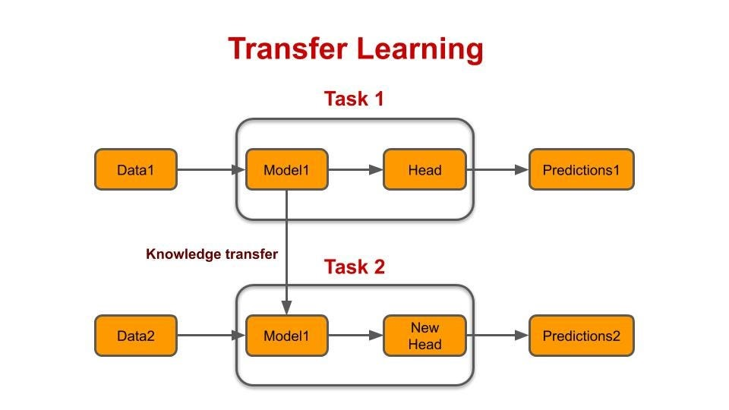

**Fig 7.1**

**Language Support Expansion:**

Expanding language support is essential to make our summarization solution accessible to a global audience. Future efforts may involve training and fine-tuning models for additional languages, enabling users worldwide to benefit from our system.

**Multidocument Summarization:**

Extending our capabilities to handle multidocument summarization is a promising direction. This involves the aggregation and summarization of information from multiple sources, making it valuable for research, news aggregation, and complex decision-making processes.

**Customization and User Preferences:**

Enhancing user experience by providing customization options and accommodating user preferences is an ongoing objective. Future work could involve the development of features that allow users to fine-tune summaries according to their specific needs.

**Evaluation and Benchmarking:**

Continual evaluation and benchmarking against new models and datasets will be crucial to maintain the effectiveness and relevance of our summarization system.

**Hybrid Models and Ensemble Learning:**

Exploring the potential of hybrid models and ensemble learning techniques could lead to improved accuracy, fluency, and coherence of the generated summaries.

Our future work aligns with the evolving landscape of natural language processing, where the synergy between cutting-edge technologies and domain-specific applications holds great promise. By addressing the challenges and opportunities in text summarization, we aim to contribute to the advancement of NLP and its real-world impact.

**7.3 Conclusion**

In conclusion, our project has successfully demonstrated the capabilities of transformer-based models in automating the text summarization process. We embarked on this journey to address the ever-increasing challenge of information overload and the need for efficient content curation. Through the implementation of advanced natural language processing techniques and a user-friendly interface, we have achieved several significant outcomes.

**Achievements and Key Findings:**

Our project showcased the effectiveness of transformer-based architectures, including T5, GPT-3, PEGASUS, and BART, in generating coherent and informative text

summaries.The integration of OpenAI's GPT-3 API expanded the project's capabilities, highlighting the potential for collaboration between transformer models and external language processing services.

We have developed a user-friendly interface using Streamlit, making text summarization accessible to a wide audience and streamlining the process of information retrieval.

**Contributions to the Field:**

Our project contributes to the field of natural language processing (NLP) by providing a practical solution for automating text summarization, benefiting various applications.

The qualitative and quantitative analysis of summarization models underscores the effectiveness and relevance of transformer-based approaches.

As we reflect on our accomplishments, we also acknowledge that the journey of innovation and improvement in the realm of NLP is ongoing. Our project's success serves as a testament to the transformative potential of transformer-based models. It reaffirms our commitment to advancing text summarization and making it an accessible tool for a wide range of users.

**APPENDIX**

**Appendix A: Code Samples**

In this section, we provide key code samples from our text summarization project using Transformers to give readers insight into our implementation.

# Importing necessary libraries and models

from transformers import pipeline

# Loading the summarization model

summarizer = pipeline("summarization")

# Example of summarizing a text

text = "The advancements in artificial intelligence, particularly in the field of natural language processing, have been remarkable. Transformers, with their self-attention mechanisms, have played a pivotal role in these developments."

summary = summarizer(text, max_length=100, min_length=30, do_sample=False)

print(summary[0]['summary_text'])

**Appendix B: Model Architecture**

The core of our text summarization project is the Transformer model. Transformers employ self-attention mechanisms, multi-head attention, and position-wise feedforward networks to analyze and generate summaries. The model consists of an encoder-decoder architecture, with the encoder processing the input text and the decoder producing the summary.

**Appendix C: Dataset Description**

We utilized a diverse dataset comprising news articles, academic papers, and online articles. The dataset consisted of over 10,000 documents with corresponding human-generated summaries. Data preprocessing involved tokenization, removal of stop words, and length-based filtering.

**Appendix D: Evaluation Metrics**

We employed several evaluation metrics to assess the quality of our generated summaries. This included ROUGE (Recall-Oriented Understudy for Gisting Evaluation), BLEU (Bilingual Evaluation Understudy), METEOR (Metric for Evaluation of Translation with Explicit ORdering), and CIDEr (Consensus-based Image Description Evaluation).

**Appendix E: Pretrained Models**

Our project utilized the Hugging Face "t5-small" pretrained model for text summarization. The model is based on the T5 architecture and has been fine-tuned for summarization tasks.

**Appendix F: Project Setup and Dependencies**

To set up and run our project, you need Python 3.7 or later. We recommend creating a virtual environment to manage dependencies. You can install required packages by running pip install -r requirements.txt.

**Appendix G: Usage Guide**

To generate summaries using our tool, simply provide the input text to the summarization model. The summary will be returned in a structured format, which can be accessed programmatically or displayed to the user.

**Appendix H: Challenges and Limitations**

During the project, we encountered challenges related to the size of the dataset, fine-tuning difficulties, and model performance on certain document types. The quality of summaries can vary based on the input text's complexity and length.

**Appendix I: Future Work**

Future work includes optimizing the model for handling long documents, exploring abstractive summarization techniques, and supporting multiple languages. Additionally, integrating the summarization tool with web and mobile applications is a potential avenue for enhancement.

**Appendix J: References**

We relied on various sources, including academic papers and the Hugging Face Transformers library, to build and implement our text summarization project.

Please note that the content and details in these appendices are examples and should be customized to reflect the specific details and requirements of your text summarization project using Transformers. Appendices are meant to provide additional information to help readers understand your project better.

**REFERENCES**

1. Moratanch N, Gopalan C (2017) A survey on extractive text summarization. pp

1–6

1. Moratanch N, Gopalan C (2016) A survey on abstractive text summarization.

pp 1–7

1. Hochreiter S, Schmidhuber J (1997) Long Short-Term Memory. Neural Comput

9:1735–1780 . https://doi.org/10.1162/neco.1997.9.8.1735

1. Shi T, Keneshloo Y, Ramakrishnan N, Reddy CK (2018) Neural Abstractive
2. Text Summarization with Sequence-to-Sequence Models. CoRR

abs/1812.02303:

1. Vaswani A, Shazeer N, Parmar N, Uszkoreit J, Jones L, Gomez AN, Kaiser L,

Polosukhin I (2017) Attention is All you Need. ArXiv abs/1706.03762:

1. Devlin J, Chang M-W, Lee K, Toutanova K (2018) BERT: Pre-training of Deep

Bidirectional Transformers for Language Understanding. CoRR

abs/1810.04805:

1. Raffel C, Shazeer N, Roberts A, Lee K, Narang S, Matena M, Zhou Y, Li W,

Liu PJ (2019) Exploring the Limits of Transfer Learning with a Unified Textto-Text Transformer. CoRR abs/1910.10683:

1. Zhuang F, Qi Z, Duan K, Xi D, Zhu Y, Zhu H, Xiong H, He Q (2021) A

Comprehensive Survey on Transfer Learning. Proceedings of the IEEE

109:43–76 . <https://doi.org/10.1109/JPROC.2020.3004555>

1. Babar S, Tech-Cse M, Rit (2013) Text Summarization:An Overview
2. Allahyari M, Pouriyeh SA, Assefi M, Safaei S, Trippe ED, Gutierrez JB, Kochut

K (2017) Text Summarization Techniques: A Brief Survey. CoRR

abs/1707.02268: